SIMATS ENGINEERING

ASSESSMENT TOOL 2
GADI REDDY PRAKASH
192365026
MARKS: 90

COURSE NAME: INTERNET PROGRAMMING COURSE CODE: CSA43

COURSE OUTCOME COVERED

CO-1: Develop well-structured, standards-compliant web pages using HTML/XHTML and XML, and apply Internet protocols and HTTP communication mechanisms for web content delivery. (L2)

Assessment Tool: Data Interpretation (Medium)

Weightage: 20%

QUESTIONS: Total Marks: 20

1: HTTP Response Analysis

A web server returns the following HTTP response header:
HTTP/1.1 200 OK
Date: Mon, 01 Apr 2026 10:00:00 GMT
Content-Type: text/html Content-Length: -150 Connection: keep-alive

Questions:

- Identify any incorrect or invalid fields in the header.
- Analyze the issue with Content-Length and explain its impact.
- Determine whether the status code matches the response correctness.
- Suggest corrections for the identified errors.

2: DOM Structure Analysis

Consider the following DOM tree representation:
<html>
<head>
<title>TestPage</title>
</head>
<body>
<div>
<p>HelloWorld
</div>
</body>
</html>

Questions:

- Identify missing or improperly closed elements.
- Analyze how the browser will interpret this structure.
- Determine the impact on rendering and layout.
- Suggest corrections to make the DOM valid.

3: GET vs POST in Login System

A login system uses two different methods:

Method URL Example Data Visibility Security Level GET /login?user=admin&pass=1234 Visible in URL Low POST /login Hidden in body Moderate

Questions:

- Interpret the differences in data transmission between GET and POST.
- Analyze which method is more suitable for login and why.
- Identify security risks in using GET for authentication.
- Suggest best practices for secure login implementation.

4: HTML Code Inspection

Analyze the following HTML snippet:

<!DOCTYPE html>
<html>
<head>
<title>Sample</title>
</head>
<body>
<h1>Welcome
<p>This is a paragraph
<img src="image.jpg">
</body>
</html>

Questions:

- Identify missing closing tags.
- Analyze issues with the <img> tag.
- Determine how browsers will handle these errors.
- Suggest a corrected version of the code.

5: Browser-Server Communication Flow

The following sequence describes a web request:

- User enters a URL in the browser
- DNS lookup occurs
- HTTP request is sent
- Server processes request
- Response is returned
- Browser renders page

Questions:

- Interpret each step in the communication flow.
- Identify where delays can occur.
- Analyze the role of DNS in the process.
- Suggest optimizations to improve performance.

Code of Conduct:

I GADI REDDY PRAKASH(192365026) (Name / Reg No) certify that this submission is my original work and that I have adhered to the guidelines specified for this assessment.
I understand that any violation of academic integrity rules will result in disciplinary action.

Signature of the student:


RUBRICS FOR CALCULATION:

Criteria | Weigh  tage |  | Level 4 (Exemplary) | Level 3 (Proficient) | Level 2  (Developing) | Level 1  (Beginning)
Understanding of Data | 25% | 22.5 | Accurately interprets all data patterns, trends, and relationships | Interprets data correctly with minor gaps | Partial understanding; misses key trends | Misinterprets or fails to understand data
Analysis | 25% | 22.5 | Provides deep analysis with strong logical reasoning and justification | Provides reasonable analysis with some  justification | Basic analysis with weak reasoning | No meaningful analysis provided
Application of Concepts | 20% | 18 | Effectively applies relevant concepts/tools to interpret data accurately | Applies concepts with minor errors | Limited application; requires guidance | Unable to apply concepts to data
Conclusion | 20% | 18 | Draws clear, meaningful conclusions with strong insights and implications | Provides valid conclusions with moderate insights | Conclusions are vague or weak | No clear or valid conclusions
Clarity | 10% | 9 | Presents interpretation clearly using proper structure, visuals, and  terminology | Generally clear with minor issues | Lacks clarity or proper structure | Poor presentation and difficult to  understand

Question 1: HTTP Response Analysis
1. Incorrect or invalid fields
Field | Problem
Content-Length: -150 | Invalid. The value must be a non-negative integer (a byte count).
Date: Mon, 01 Apr 2026 | Inconsistent. 1 April 2026 is a Wednesday, not a Monday. HTTP dates must follow the RFC 9110 format, with a correct weekday, in GMT.
Content-Type: text/html | Valid, but no charset is given. text/html; charset=UTF-8 is recommended, otherwise the browser guesses the encoding.
Status line, Connection | Syntactically valid.
2. The Content-Length issue and its impact
Content-Length tells the client exactly how many bytes of body to read. A negative byte count is impossible, so the message is malformed.
- Clients may reject the response as invalid (browsers show errors such as ERR_INVALID_HTTP_RESPONSE), or may treat the length as unknown.
- With Connection: keep-alive, the length is also used for message framing. If the client cannot tell where the body ends, the next response on the same connection gets misread (connection desynchronisation), causing hanging pages or truncated content.
- Proxies and servers that parse the value differently open the door to HTTP request/response smuggling attacks.
- Download progress bars and caching also become unreliable.
3. Does the status code match?
The status 200 OK says the request succeeded, but the response itself is malformed, so the status is not trustworthy. 200 is only appropriate if the headers are valid and the body really matches them. If the server cannot produce a valid response, it should return 500 Internal Server Error. If the server’s bug is in a proxy or gateway, 502 Bad Gateway fits.
4. Corrections
HTTP/1.1 200 OK
Date: Wed, 01 Apr 2026 10:00:00 GMT
Content-Type: text/html; charset=UTF-8
Content-Length: 1500
Connection: keep-alive
- Content-Length must equal the real body size in bytes. Alternatively, use Transfer-Encoding: chunked (and not both).
- Generate the Date header automatically from the server clock rather than hand-writing it.
- Add charset=UTF-8.
Conclusion: Content-Length: -150 is the critical fault, and the wrong weekday and missing charset are secondary. A 200 status cannot make a malformed response valid, so servers must compute headers programmatically and validate them.
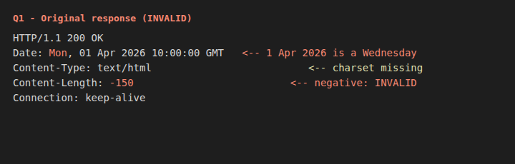

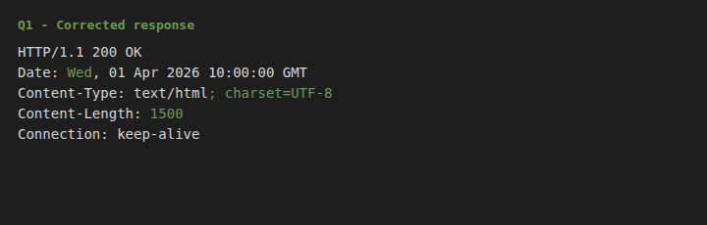

Question 2: DOM Structure Analysis
1. Missing or improperly closed elements
- <p>HelloWorld has no closing </p>.
- No <!DOCTYPE html>, no lang on <html>, and no <meta charset>.
- No semantic wrapper (<main>), and the text lacks a space (“HelloWorld” should probably be “Hello World”).
HTML5 allows </p> to be omitted when the parent closes, so this is not a fatal error, but it is poor practice and fails strict validation.
2. How the browser interprets it
The HTML5 parser applies error recovery. When it meets </div> while <p> is still open, it implicitly closes the <p> first. The resulting DOM is:
html → head → title → "TestPage"
→ body → div → p → "HelloWorld"
Because there is no DOCTYPE, the page is rendered in quirks mode.
3. Impact on rendering and layout
- The text still appears, as a paragraph with default top and bottom margins, since the parser repairs the missing tag.
- Quirks mode changes the box model, line heights and font inheritance in some elements, so the layout can differ across browsers.
- In more complex pages, an unclosed tag can swallow following content into the wrong parent, so CSS selectors and layout break.
- Without charset, special characters may appear garbled.
4. Corrected DOM
html
<!DOCTYPE html>
<html lang="en">
<head>
<meta charset="UTF-8">
<meta name="viewport" content="width=device-width, initial-scale=1.0">
<title>TestPage</title>
</head>
<body>
<div>
<p>Hello World</p>
</div>
</body>
</html>
Conclusion: the browser repairs the missing </p>, so the visible output looks fine, but relying on error recovery is risky. Explicit closing tags and a DOCTYPE give a predictable DOM and consistent rendering.

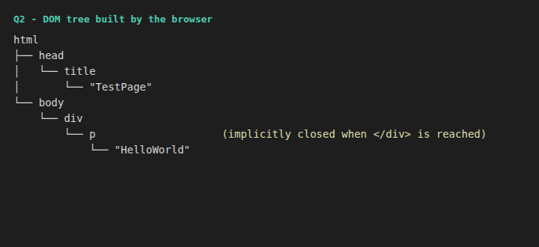


Question 3: GET vs POST in a Login System
1. Differences in data transmission
Aspect | GET | POST
Data location | URL query string | Request body
Visibility | Visible in address bar and history | Not shown in URL
Example | GET /login?user=admin&pass=1234 | POST /login + body user=admin&pass=1234
Size limit | About 2,000 characters (practical) | No practical limit
Caching/bookmark | Cached and bookmarkable | Not cached by default
Semantics | Safe, idempotent: retrieves data | Not idempotent: changes server state
2. Which is more suitable, and why
POST is the suitable choice. A login submits secrets and creates a session, which is a state-changing action. POST keeps credentials out of URLs, history, bookmarks and cache. Note that POST is only moderately secure, because the body is still plain text unless the connection uses HTTPS.
3. Security risks of GET for authentication
- Credentials are stored in browser history and bookmarks.
- They are written to server, proxy and CDN access logs.
- They leak through the Referer header to third-party sites.
- Shoulder-surfing: anyone looking at the screen can read the password.
- URLs can be cached, shared or copied by mistake.
- Links can be crafted for CSRF-style attacks because GET requests are easily triggered.
4. Best practices for secure login
- Use HTTPS/TLS everywhere, with HSTS.
- Always use POST, with the body encoded.
- Hash passwords with bcrypt/Argon2 and a salt. Never log or store plain text.
- Add CSRF tokens. Set cookies with Secure, HttpOnly and SameSite.
- Use rate limiting, account lockout and CAPTCHA against brute force. Add MFA.
- Use parameterised queries to prevent SQL injection, and give generic error messages (“Invalid credentials”).
- Regenerate the session ID after login and set Cache-Control: no-store.
Conclusion: GET exposes credentials in multiple places and must never be used for login. POST over HTTPS, combined with hashing, CSRF protection and rate limiting, is the correct secure design.

Question 4: HTML Code Inspection
1. Missing closing tags
- <h1>Welcome is missing </h1>.
- <p>This is a paragraph is missing </p>.
- Additionally, the <p> sits inside the <h1>, which is invalid nesting because headings accept only phrasing content.
2. Issues with the <img> tag
- <img> is a void element, so it needs no closing tag. That part is fine.
- Missing alt attribute. This is required by the HTML standard. It is critical for screen readers, and it shows text if the image fails to load.
- No width and height, so the page shifts when the image loads (poor Cumulative Layout Shift).
- image.jpg may not exist, producing a broken-image icon. Optionally add loading="lazy".
3. How browsers handle these errors
- The parser does not stop. It auto-closes the open elements when </body> is reached.
- Since <p> does not close the <h1>, the paragraph becomes a child of <h1> and inherits its large, bold style (see q4_before.png: the whole text appears as a big heading).
- The image renders if found. If not, a broken-image placeholder is shown.
- Different browsers and validators may report the errors differently, but the HTML5 spec makes recovery consistent in modern browsers.
4. Corrected code
html
<!DOCTYPE html>
<html lang="en">
<head>
<meta charset="UTF-8">
<meta name="viewport" content="width=device-width, initial-scale=1.0">
<title>Sample</title>
</head>
<body>
<header>
<h1>Welcome</h1>
</header>
<main>
<p>This is a paragraph</p>
<img src="image.jpg" alt="Sample illustration" width="200" height="100">
</main>
</body>
</html>
Conclusion: the missing closing tags cause the paragraph to nest inside the heading, which changes its styling. The <img> needs alt and dimensions. Proper closing, nesting and attributes give a valid, accessible page.


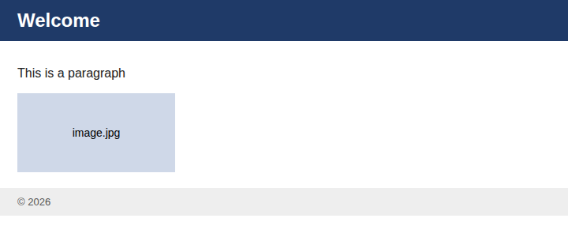

Question 5: Browser-Server Communication Flow
1. Interpretation of each step
- User enters a URL: the browser parses it into scheme, host, path and port. It checks its cache and HSTS list, and may upgrade to HTTPS.
- DNS lookup: the domain name (e.g. example.com) is translated into an IP address. Before the request can be sent, a TCP handshake (and TLS handshake for HTTPS) opens a connection.
- HTTP request sent: the browser sends the request line (GET / HTTP/1.1) and headers (Host, User-Agent, Accept, Cookie).
- Server processes the request: the web server routes it to the application, which runs the logic, queries databases and builds the response.
- Response returned: the server sends the status line (e.g. 200 OK), headers (Content-Type, Content-Length, caching headers) and the body (HTML).
- Browser renders: it parses HTML into the DOM and CSS into the CSSOM, combines them into the render tree, then performs layout and paint. Extra requests for CSS, JS and images are made, and JavaScript runs.
2. Where delays occur
Stage | Cause of delay
DNS lookup | Slow resolver, uncached domain, many domains
TCP/TLS | High round-trip time (distance), multiple handshakes
Request/response | Limited bandwidth, large payloads
Server processing | Slow code, heavy database queries, overloaded server (high TTFB)
Rendering | Render-blocking CSS/JS, large images, heavy JS execution
3. Role of DNS
DNS is the internet’s phonebook. Computers communicate using IP addresses, but people use names. The lookup goes: browser cache → OS cache → recursive resolver (ISP) → root server → TLD server (.com) → authoritative name server, which returns the IP. DNS also enables load balancing and failover (multiple IPs) and CDN routing to the nearest server. Results are cached according to the record’s TTL, which reduces repeat lookups. Because nothing else can happen until the IP is known, slow DNS delays the entire page load.
4. Optimisations
- DNS: use fast DNS providers, dns-prefetch, preconnect, and sensible TTLs.
- Network: use a CDN, HTTP/2 or HTTP/3, TLS 1.3 and keep-alive connections.
- Payload: enable Gzip/Brotli compression, minify CSS/JS, and use modern image formats (WebP/AVIF) with loading="lazy".
- Caching: set Cache-Control/ETag for browser caching, and use server-side caching (Redis).
- Server: optimise database queries with indexes, scale horizontally and use a load balancer.
- Rendering: place CSS in <head>, load JS with defer or async, inline critical CSS and reduce redirects.
Conclusion: page load time is the sum of DNS, connection, server and rendering time. Reducing each stage with caching, CDNs, compression and efficient front-end code gives the biggest performance gains.

